

**COMP-SCI 5590 - 0002   Special Topics**

**Mobile App Development**

ICE 7: Integrating Calendar to Android App

Lesson Plan

Calendar API is available as of Android 4.0.It is used for displaying and selecting dates. The supported range of dates of this calendar is configurable. User selects a date by clicking on it and can also scroll & to a desired date. Developers can also set minimum and maximum date shown in calendar view.

We will also learn how to publish apps to Google Play store.

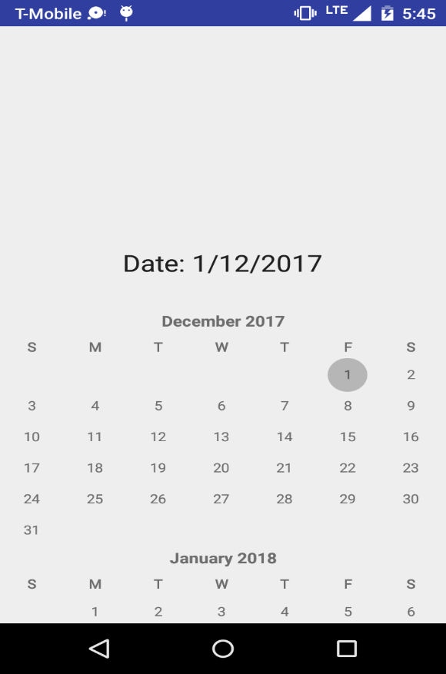

In Class Exercise

1. Add calendar to one of the activities of existing project
2. Project it to Current existing date
3. When user clicks on any of the dates then the date should be displayed as shown in image.
4. Generate signed APK for the source code generated above and share the screenshots of the whole process. (points will be deducted for not sharing proper screenshots)